# 

**Temenos Software Services**

**Installation Guide**

|  |  |
| --- | --- |
| Client/Project Name: | **CLCU** |
| Client CR Reference: | **CR_Account_v1.0** |
| Developed By: | **Banktech Software Services Ltd** |
| Temenos CR Reference: |  |

# Document Modification History

|  |  |  |  |
| --- | --- | --- | --- |
| **Rev.** | **Date** | **Author** | **Description** |
| 1.0 | 2021-05-31 | Nirmal Kumar N & Poorani R | First version |
| 1.0 | 2021-05-31 | Bharathi Raja Ponmudi | Reviewed & Baselined |

# Change Request Summary

|  |
| --- |
| Initial Account Package Development as per CSD - Accounts V1.3 |

# Table of Contents

Document Modification History 2

Change Request Summary 2

Table of Contents 3

1. System Requirement 4

2. General Considerations 4

3. Contents of the Package 4

3.1. Customization Objects 4

3.2. Insert Files 4

3.3. Routines 4

3.4. Data Records 5

4. Steps for Installing the Package 9

4.1. Pre-Installation Steps 9

4.2. Installation Steps 10

4.2.1. File movement & .properties 10

4.2.2. Installing T24 package 10

4.3. Post-Installation Steps 12

5. System Configuration 12

6. Special Instructions 13

# System Requirement

TAFJ – R19 or above

JAVA – 1.8.0_111 or above

Jboss - 7.0.0.GA or above

# General Considerations

When transferring the pack via FTP the transport method must be set to binary.

# Contents of the Package

## Customization Objects

N/A

## Insert Files

Precompile jar

* Cu_Account.jar

## Routines

Class files included within Cu_Account.jar, This Jar is an Ireland specific pack.

* Cu.Account.Component
* CU.B.DRAW
* CU.B.DRAW.BULK.PAY
* CU.B.DRAW.BULK.PAY.LOAD
* CU.B.DRAW.BULK.PAY.POST
* CU.B.DRAW.BULK.PAY.SELECT
* CU.B.DRAW.BULK.PAY.SUSP
* CU.B.DRAW.BULK.PAY.SUSP.LOAD
* CU.B.DRAW.BULK.PAY.SUSP.SELECT
* CU.B.GET.CAR.DRAW.LIST.TODAY
* CU.CONTRA.ACC.TRANSFER
* CU.CONTRA.ACC.TRANSFER.FIELDS
* CU.DBI.STO
* CU.DBI.STO.FIELDS
* CU.DRAW
* CU.DRAW.AUTHORISE
* CU.DRAW.FIELDS
* CU.DRAW.ID
* CU.DRAW.RECORD
* CU.DRAW.VALIDATE
* CU.E.BLD.DRAW.ACCOUNT.LIST
* CU.E.NOF.DRAW.WINNERS
* CU.OFS.CHECK.RESP
* CU.PRIZE.DRAW
* CU.PRIZE.DRAW.FIELDS
* CU.STO.CAR.DRAW.AMT
* CU.V.AUTH.STO.CUST
* CU.V.AUTH.STO.DBI.CUST
* CU.V.CHR.SO.CAR.DRAW.ENTRY.FEE
* CU.V.CHR.STO.DBI
* CU.V.CHR.STO.STD.FI2
* E.NOF.INACTIVE.MONTH
* NOFILE.E.CU.CAR.DRAW.STO

## 3.4. Data Records

**Package 1: -**

Data Records included within **CLCU001-ACCOUNT.LT.PACK**

* LOCAL.TABLE>L.DIRT.EXP.RES

**Package 2: -**

Data Records included within **CLCU001-ACCOUNT.DATA.RECORD**

* CATEGORY>12900
* CATEGORY>7314
* CATEGORY>1001
* CATEGORY>6002
* CATEGORY>6015
* CATEGORY>7310
* CATEGORY>7311
* CATEGORY>7313
* ACCOUNT>EUR129000001
* ACCT.GEN.CONDITION>1
* ACCT.GEN.CONDITION>2
* ACCT.GEN.CONDITION>4
* ACCT.GEN.CONDITION>9
* ACCT.GEN.CONDITION>11
* ACCT.GEN.CONDITION>13
* ACCT.GEN.CONDITION>14
* ACCT.GROUP.CONDITION>1EUR
* ACCT.GROUP.CONDITION>2EUR
* ACCT.GROUP.CONDITION>4EUR
* ACCT.GROUP.CONDITION>9EUR
* ACCT.GROUP.CONDITION>11EUR
* ACCT.GROUP.CONDITION>13EUR
* ACCT.GROUP.CONDITION>14EUR
* IN.IBAN.STRUCTURE>IE
* EB.PARAM>ALL-EM.RBHP.ACCTCATEG.OVERVIEW
* ENQUIRY>EM.RBHP.OPMG.AC.GIC.INACT
* ENQUIRY>EM.AIO.ACCOUNT.LIST
* ENQUIRY>EM.SCV.ACCOUNT.LIST
* VERSION>ACCOUNT,EM.SCV.NEW.CURRENT
* VERSION>ACCOUNT,EM.SCV.NEW.RS
* VERSION>ACCOUNT.CLOSURE,EM.INPUT
* VERSION>ACCOUNT,EM.SCV.NEW.FAMILY
* VERSION>ACCOUNT,EM.SCV.NEW.SAV.STMP
* VERSION>ACCOUNT,EM.SCV.NEW.PRN.SHR
* VERSION>ACCOUNT,EM.SCV.NEW.PRN.DEP
* VERSION>ACCOUNT,EM.SCV.NEW.DEP.ACCOUNT
* VERSION> ACCOUNT,EM.GICSIGN
* TEC.ITEMS>EM.PAYMENT.ACCT.OVERDRAWN
* EM.TM.TASK.TEMPLATE>PAYMENT.ACCOUNT.OVERDRAWN
* EM.TM.EVENT>EM.PAYMENT.ACCT.OVERDRAWN
* BROWSER.TOOLS>EM.SCV.NEW.CURRENT.ACCOUNT
* BROWSER.TOOLS>EM.SCV.NEW.RS.ACCOUNT
* BROWSER.TOOLBAR>EM.AIO.AC.ACCT.MENU
* BROWSER.TOOLS>EM.SCV.NEW.FAMILY.ACCOUNT
* BROWSER.TOOLS>EM.SCV.NEW.SAVINGS.STAMPS
* BROWSER.TOOLS> EM.SCV.NEW.NPRN.SHR.ACCOUNT
* BROWSER.TOOLS> EM.SCV.NEW.NPRN.DEP.ACCOUNT
* BROWSER.TOOLBAR>EM.AIO.DEP.ACCT.MENU
* BROWSER.TOOLBAR>EM.SCV.ACCOUNT.MENU
* BROWSER.TOOLS>EM.SCV.LNAPP.AA.NEW.LBL
* BROWSER.TOOLBAR>EM.AIO.SAV.AC.INACTIVE.HDR
* EB.COMPOSITE.SCREEN>OPENDE.ACCOUNT
* BROWSER.TOOLS>EM.AIO.ACC.LIST.OPENED
* EB.COMPOSITE.SCREEN>EM.AIO.ACCOUNT.AMEND
* BROWSER.TOOLS>EM.AIO.ACCOUNT.AMEND
* BROWSER.TOOLS>EM.AIO.DECEASED.CUS.LIST
* EB.COMPOSITE.SCREEN>EM.AIO.ACCT.INACTIVE.MARKER.RESET
* EB.COMPOSITE.SCREEN>EM.RBHP.LNAG.MAIN
* BROWSER.TOOLS>EM.RBHP.OPMG.ACCT.INACTIVE.MARKER
* ENQUIRY>CU.CDD
* BROWSER.TOOLS>EM.CUSTOMER.DUE.DILIGENCE.TTL
* BROWSER.TOOLBAR>EM.CUSTOMER.DUE.DILIGENCE.HDR
* EB.COMPOSITE.SCREEN>EM.CUSTOMER.DUE.DILIGENCE
* BROWSER.TOOLS>EM.CUSTOMER.DUE.DILIGENCE
* ENQUIRY>CU.DEATH.PAID.REPORT
* BROWSER.TOOLS>EM.AIO.CU.DEATH.PAID.REPORT.TTL
* BROWSER.TOOLBAR>EM.AIO.CU.DEATH.PAID.REPORT.HDR
* EB.COMPOSITE.SCREEN>EM.AIO.CU.DEATH.PAID.REPORT
* BROWSER.TOOLS>EM.AIO.CU.DEATH.PAID.REPORT
* ENQUIRY>CU.PRIZE.DRAW.MEMBER
* BROWSER.TOOLS>CU.PRIZE.DRAW.MEMBER.TTL
* BROWSER.TOOLBAR>CU.PRIZE.DRAW.MEMBER.HDR
* EB.COMPOSITE.SCREEN>EM.CU.PRIZE.DRAW.MEMBER
* BROWSER.TOOLS>CU.PRIZE.DRAW.MEMBER
* CU.PARAMETER>ALL-ACCT.INACTIVE.MNTHS
* STANDARD.SELECTION>NOFILE.ACC.INACTIVE.MNTHS
* ENQUIRY>ACCT.INACTIVE.MONTHS
* BROWSER.TOOLS>EM.ACCT.INACTIVE.MONTHS.TTL
* BROWSER.TOOLBAR>EM.ACCT.INACTIVE.MONTHS.HDR
* EB.COMPOSITE.SCREEN>EM.ACCT.INACTIVE.MONTHS
* BROWSER.TOOLS>EM.ACCT.INACTIVE.MONTHS
* BROWSER.TOOLBAR>EM.AIO.SAV.REPS
* CU.PARAMETER>ALL-DRAW.PARAMETERS
* STANDARD.SELECTION>CU.DBI.STO
* FILE.CONTROL>CU.DBI.STO
* PGM.FILE>CU.DBI.STO
* VERSION>STANDING.ORDER,CU.DRAW
* VERSION>STANDING.ORDER,DBI.STO
* VERSION>STANDING.ORDER,PPI.STO
* VERSION>STANDING.ORDER,EM.STD.FI
* VERSION>FUNDS.TRANSFER,DRAW.OFS
* PGM.FILE>CU.V.CHR.STO.STD.FI
* PGM.FILE>CU.V.CHR.STO.PPI
* PGM.FILE>CU.V.CHR.STO.DBI
* PGM.FILE>CU.V.INP.STO.CUST.AGE
* PGM.FILE>CU.V.AUTH.STO.DBI.CUST
* EB.API>CU.V.CHR.STO.STD.FI
* EB.API>CU.V.CHR.STO.PPI
* EB.API>CU.V.CHR.STO.DBI
* EB.API>CU.V.INP.STO.CUST.AGE
* EB.API>CU.V.AUTH.STO.DBI.CUST
* EB.API>CU.V.CHR.SO.CAR.DRAW.ENTRY.FEE
* CU.PARAMETER>ALL-DBI.PARAMETERS
* CU.PARAMETER>ALL-PPI.PARAMETERS
* CU.PARAMETER>ALL-DRAW.BULK.PARAMETERS
* OFS.SOURCE>FT.DRAW
* BROWSER.TOOLS>EM.SCV.NEW.FIXED.STO
* BROWSER.TOOLS>EM.SCV.NEW.DBI.STO
* BROWSER.TOOLS>EM.SCV.NEW.PPI.STO
* BROWSER.TOOLBAR>EM.SCV.STANDING.ORDERS.MENU
* PGM.FILE>CU.OFS.CHECK.RESP
* ENQUIRY>CU.DRAW.ACCOUNT.LIST
* FT.TXN.TYPE.CONDITION>ACCU
* EB.API>CU.V.AUTH.STO.CUST
* BROWSER.TOOLS>EM.SCV.NEW.DRAW.STO
* PGM.FILE>CU.PRIZE.DRAW
* FILE.CONTROL>CU.PRIZE.DRAW
* STANDARD.SELECTION>CU.PRIZE.DRAW
* FT.TXN.TYPE.CONDITION>ACBI
* VERSION>STANDING.ORDER,SEPA.FIXAMT.CT
* EB.ERROR>EB-CU.OWN.REC.ERR
* EB.API>CU.V.INP.USER.OWN.CUS.ACC
* VERSION.CONTROL>ACCOUNT
* VERSION.CONTROL>CUSTOMER
* ENQUIRY>CU.SEPA.OUTWARD.PAY.INFO
* ENQUIRY>CU.SEPA.INWARD.PAY.INFO

# Steps for Installing the Package

## Pre-Installation Steps

* + - 1. Unzip all jar files which are shared in tdzclcuiedevft storage account mention CR docs.

Transfer **Cu_Account.jar** file into locallib folder (X:\t24\jboss\modules\com\temenos\t24\main\locallib) that will be added to precompiles in tafj.properties.

Generate module xml for the added jar. Add the dependencies available in module xml.

Path :- X:\t24\jboss\modules\com\temenos\t24\main\Modules.xml

Beginning of file screenshot

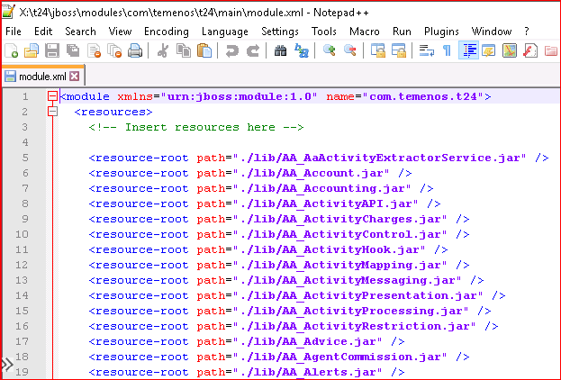

**.**

**.**

**.**

Change and tail of file screenshot

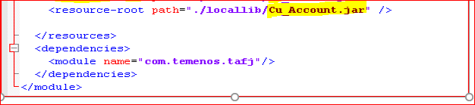

2. Reverse the record ‘3‘ in ACCT.GEN.CONDITION.

Once above steps are completed **Restart Jboss**

## Installation Steps

### File movement & .properties

N/A

### Installing T24 package

For Data Records Deployment;

Unzip all BCON files which are shared in tdzclcuiedevft storage account mentioned CR docs.

Pack order details:

1. CLCU001-ACCOUNT.LT.PACK
2. CLCU001-ACCOUNT.DATA.RECORD

**Package 1: - CLCU001-ACCOUNT.LT.PACK**

The package has been delivered as a Build Control Unit, Please follow the steps given below

* Open a new record **CLCU001-ACCOUNT.LT.PACK** in BUILD.CONTROL, in input mode.
* Enter the value of field ‘RELEASE’ as ACTION
* Enter the release path where the package **CLCU001-ACCOUNT.LT.PACK** has been placed (for example,/F.BCON.DATA/RELEASE)
* Enter Y for RELOAD PACKAGE AGAIN?
* Enter “BUILD.CONTROL” in OFS.SOURCE record.
* Commit the record
* Open the record in Verify mode
* Press F5. Build Control will automatically release the programs, compile them.
* After compiling, BUILD.CONTROL will raise a prompt to Sign Off and Sign ON again.
* Sign Off from T24 and Log out of jBASE
* Log back in, Sign into T24 and ‘V’erify the same BUILD.CONTROL record.
* BUILD.CONTROL will now create local ref definitions, create I–descriptors, restore the records and authorise them as appropriate.
* Verify if the records are authorized.

**Manual Steps**

**i)a) Add to LOCAL.REF.TABLE>ACCOUNT**

|  |  |
| --- | --- |
| **LOCAL TABLE NO** | **SUB ASSOC CODE** |
| L.DIRT.EXP.RES |  |

b) Rebuild STANDARD.SELECTION>CUSTOMER

* Proceed this activity in classic session.
* Go to field no – 28
* Input – Y and Enter
* Ctrl V

c) **Restart Jboss**

Package 2: - **CLCU001-ACCOUNT.DATA.RECORD**

The package has been delivered as a Build Control Unit, Please follow the steps given below

* Open a new record **CLCU001-ACCOUNT.DATA.RECORD** in BUILD.CONTROL, in input mode.
* Enter the value of field ‘RELEASE’ as ACTION
* Enter the release path where the package **CLCU001-ACCOUNT.DATA.RECORD** has been placed (for example,/F.BCON.DATA/RELEASE)
* Enter Y for RELOAD PACKAGE AGAIN?
* Enter “BUILD.CONTROL” in OFS.SOURCE record.
* Commit the record
* Open the record in Verify mode
* Press F5. Build Control will automatically release the programs, compile them.
* After compiling, BUILD.CONTROL will raise a prompt to Sign Off and Sign ON again.
* Sign Off from T24 and Log out of jBASE
* Log back in, Sign into T24 and ‘V’erify the same BUILD.CONTROL record.
* BUILD.CONTROL will now create local ref definitions, create I–descriptors, restore the records and authorise them as appropriate.
* Verify if the records are authorized.

## Post-Installation Steps

After completing the above, the steps mentioned below should be carried out in the sequence of order as mentioned.

1. Review all the pack deployment one after another to check whether if all records are authorised Successfully like below in browser command line.

BUILD.CONTROL S CLCU001-ACCOUNT.LT.PACK

BUILD.CONTROL S CLCU001-ACCOUNT.DATA.RECORD

1. If any record falls in IHLD status kindly authorise the record manually.

# System Configuration

1. Add the below mentioned local field to the LOCAL.REF.TABLE>USER application.

**CUSTOMER.ID**

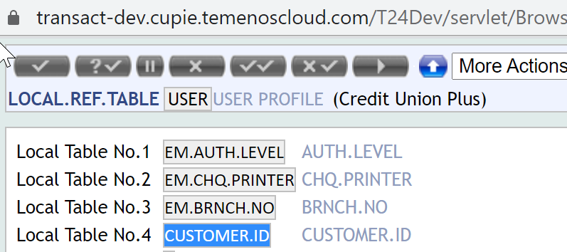

1. Rebuild STANDARD.SELECTION>USER.
2. Change the below mentioned field details in COMPANY>IE0010001 Application.

**Iban Bank Id>EDCN**

**Iban Branch Id>991042**

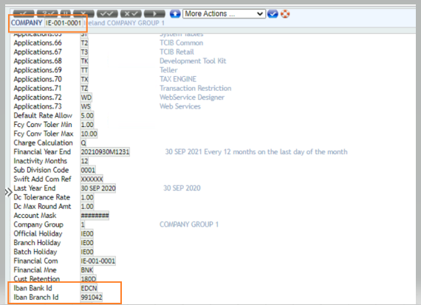

1. Restart jboss

# Special Instructions

N/A